**Sites for referencing Bucket details (WIP)**

* This site follows quite similar way of SmartFlowDrain pattern excluding IOT. Quite good for referencing the dimension and other measurements required for our project.

<http://www.foxenviro.com.au/silt-traps.html>

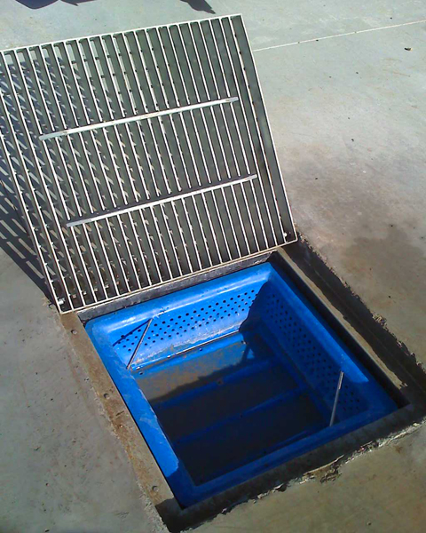

* This site can be used to contact plastic bucket manufacturers:   
  <https://ashtownpackaging.ie/contact/>